2D Football Game
USING PYTHON & PYGAME

Submitted By

Student Name | Student ID
MD. SHAJAHAN HOSSAIN | 191-15-2542

PROJECT REPORT
This Report Presented in Partial Fulfillment of the course CSE316:
Artificial Intelligence Lab in the Computer Science and Engineering Department


DAFFODIL INTERNATIONAL UNIVERSITY
Dhaka, Bangladesh
April 16, 2026

DECLARATION
We hereby declare that this lab project has been done by us under the supervision of Fahiba Farhin, Assistant Professor, Department of Computer Science and Engineering, Daffodil International University. We also declare that neither this project nor any part of this project has been submitted elsewhere as lab projects.

Submitted To:

Fahiba Farhin
Assistant Professor
Department of Computer Science and Engineering
Daffodil International University

Submitted by

MD. SHAJAHAN HOSSAIN
ID: 191-15-2542
Dept. of CSE, DIU

COURSE & PROGRAM OUTCOME
This project was undertaken as part of the CSE332 Compiler Design Lab course. The course outcomes (COs) and their mapping to Program Outcomes (POs), Bloom's Taxonomy Learning Domains, Knowledge Profile (KP), Complex Engineering Problem (CEP) attributes, and Complex Engineering Activities (CEA) attributes are as follows:
Table 1: Course Outcome Statements
COs | CO Statements
CO1 | Design and implement a user interface for inputting expressions.
CO2 | Develop the core logic to convert mathematical expressions.
CO3 | Implement error handling and validation for user input
CO4 | Test and deploy the expression converter application
Table 2: Mapping of CO, PO, Blooms, KP, CEP and CEA
COs | POs | Learning Domains (Blooms) | Knowledge Profile (KP) | Complex Engineering Problem (CEP) | Complex Engineering Activities (CEA)
CO1 | PO1 | C3 | K2 | EP1
CO2 | PO2 | C4 | K3 | EP2
CO3 | PO10 | C4 | K5 | EP3 | EA1
CO4 | PO3 | C5 | K4 | EP5
(Note: Bloom's levels C3, C4, C5 correspond to Apply, Analyze, Evaluate respectively. See justifications below based on the CSE412 outline)
The mapping justification for these outcomes is provided in Chapter 4 (Section 4.3) of this report.

Contents
DECLARATION 2
COURSE & PROGRAM OUTCOME 3
Chapter 1 6
Introduction 6
1.1 Introduction: 6
1.2 Motivation: 6
1.3 Objectives: 6
1.4 Feasibility Study: 6
1.5 Gap Analysis: 7
1.6 Project Outcomes: 7
Chapter 2 8
Proposed Methodology/ Architecture 8
2.1 Requirement Analysis & Design Specification 8
2.2 Methodology 8
2.2 Overall Project Plan: 10
Chapter 3 11
Implementation Details 11
3.1 Game Mechanics: 11
3.2 Controls: 11
3.3 Result : 12
Chapter 4 13
Engineering Standards and Mapping 13
4.1 Impact on Society and Learning: 13
4.2 Project Management and Team Collaboration: 13
4.3 Complex Problem Solving Mapping: 13
Chapter 5 16
Conclusion 16
5.1 Summary: 16
5.2 Limitations: 16
5.3 Future Enhancements 16
References 17

Chapter 1

Introduction
2D Football Game is an engaging 2D sports simulation developed using Python and Pygame. The game features a one-on-one football match between two iconic players, with both single-player and multiplayer modes. The project integrates core game development concepts such as real-time input handling, animation, collision detection, and AI logic, providing a fun and interactive football experience.

1.1 Introduction:
The "2D Football Game" is an interactive, real-time football simulation built with Python and Pygame. It features two of the world’s most iconic players, Messi and Ronaldo, in a one-on-one 2D football match. With support for both single-player (AI) and two-player modes, the game explores key AI concepts such as input handling, collision detection, basic physics, and simple decision-making.

1.2 Motivation:
We aimed to combine our love for football and coding to create a fun and educational project. Football is universally appreciated, and creating a Python-based version offers a practical way to dive into game mechanics, AI, and UI development — all while learning how to manage physics and ren

1.3 Objectives:
- Create a fully playable 2D football game with AI and two-player support.
- Implement real-time player and ball mechanics using Pygame.
- Integrate a scoring system, timer, and UI elements like menus and win/loss screens.
- Build AI logic to control one player in single-player mode.
- Apply animation and collision detection to simulate real-world interactions.

1.4 Feasibility Study:
This project is highly feasible both technically and economically. Python is a free, open-source language with rich libraries like Pygame that support 2D game development efficiently. The game can run on any basic computer with a Python environment installed — no costly software or hardware is needed. From a development standpoint, game logic such as movement, collision, AI tracking, and animations are manageable through modular design and Pygame’s event loop system. The lightweight nature of the application ensures smooth performance even on low-spec machines, making it ideal for student projects and learning environments..

1.5 Gap Analysis:
While there are many football games available online, most are built with complex engines and require advanced graphics or paid platforms. There’s a lack of simple, open-source Python-based football games that demonstrate core concepts such as input handling, AI behavior, and physics simulation. Educational games built with Pygame often stop at basic arcade mechanics and rarely include AI or multiplayer support. This project fills that gap by providing a well-documented, functional 2D football game that combines AI, animation, and multiplayer mechanics, specifically targeted at learners and developers seeking to understand game logic without relying on heavy game engines.

1.6 Project Outcomes:
The final outcome of this project is a 2D football game that supports both single-player and multiplayer modes. It offers a user-friendly interface, responsive controls, and smooth gameplay. The inclusion of basic AI logic gives users the ability to play solo matches, while the local two-player mode enables competitive gameplay. The modular code structure allows for future upgrades, such as enhanced AI, power-ups, or sound integration. Overall, the project meets the intended learning goals and provides a practical demonstration of game development using Python and Pygame.

Chapter 2

Proposed Methodology/ Architecture
The development of the 2D Football Game required clear identification of both functional and non-functional requirements. The core idea was to build a modular, interactive football simulation using Python and Pygame, suitable for both single and two-player gameplay.

2.1 Requirement Analysis & Design Specification
Functional Requirements:
- Control two individual football players.
- Real-time ball movement and shooting mechanics.
- AI logic for single-player mode.
- Score detection when the ball crosses the goal line.
- Visual effects and animations for goals.
- Display match timer, scoreboards, and menus.
Non-Functional Requirements:
- Smooth gameplay with at least 60 FPS.
- Intuitive user interface.
- Cross-platform compatibility (Windows/Linux/macOS).
- Lightweight and easy to run on low-end machines.

Design Specification:
- Use sprite-based animation for player and ball movement.
- Include modules for UI, game mechanics, physics, AI, and event handling.
- Design menus and pause functionality with button interactions.
- Integrate keyboard-based controls for both players...

2.2 Methodology
- Modular Development
Each feature (like scoring, player movement, or AI) was built as an independent Python class or function, allowing easy testing and maintenance.
- Game Loop Architecture
The heart of the game is a while-loop that runs continuously, handling events, updating object positions, and redrawing the display window at each frame.
- Collision Detection
The ball and players are treated as rectangles, and Pygame’s built-in collision functions are used to check for contact. Scoring is triggered when the ball touches the goal post area.
- Artificial Intelligence
In single-player mode, a simple AI moves the opposing player vertically to follow the ball’s Y-axis and attempts to kick the ball when close enough.
- User Interface
The game includes a main menu, pause screen, and win/lose screen. UI elements were designed using Pygame's surface rendering and font drawing tools.

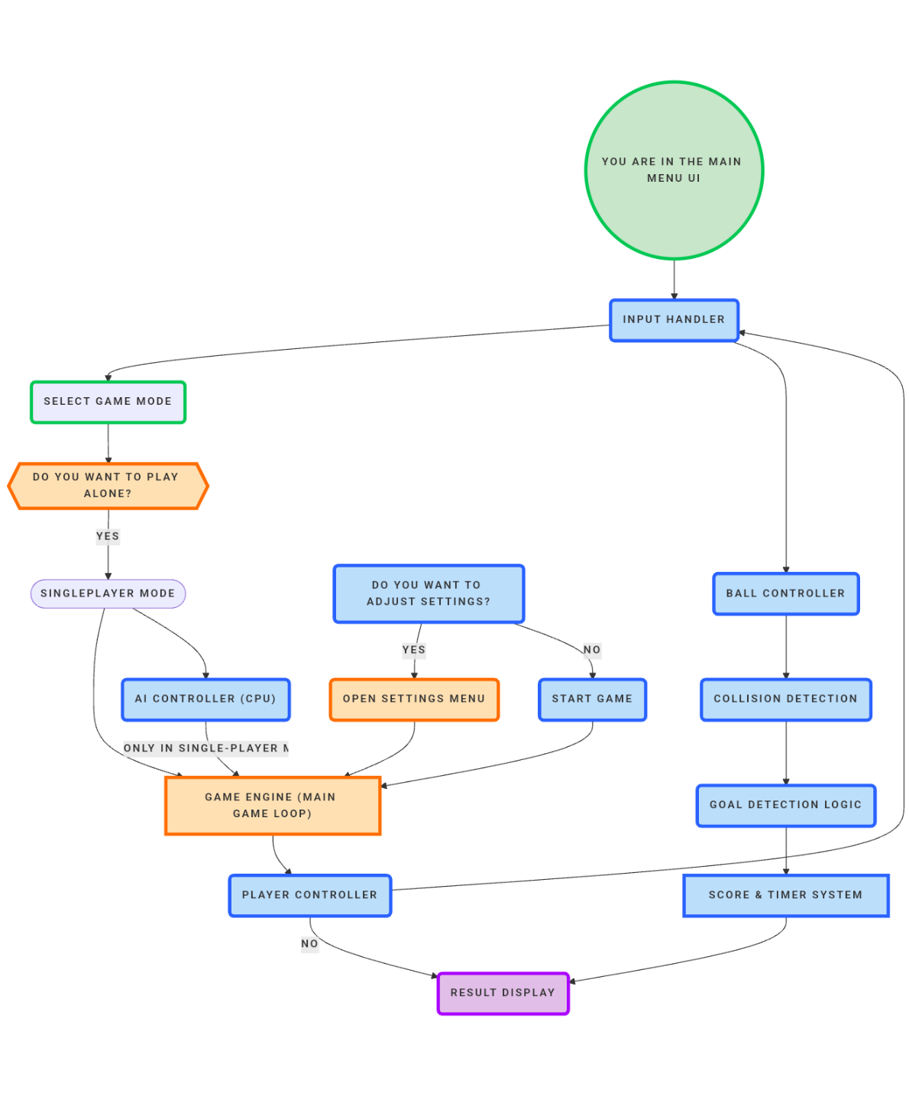
Workflow:

2.2 Overall Project Plan:
Phase | Tasks
Requirement Gathering | Define game features, modes, controls, and visual style.
Environment Setup | Install Python, Pygame, and configure the development environment
Design Phase | Plan object layout, screen dimensions, control mapping, and architecture
Development Phase | Implement game loop, mechanics, AI, scoring system, and UI.
UI & Graphics Integration | Add menus, text overlays, animations, and goal effects
Testing & Debugging | Identify and fix gameplay bugs, AI flaws, and UI glitches
Final Integration | Assemble all components, polish graphics and timing
Documentation | Prepare report, add comments to code, and write a user guide.
Submission & Presentation | Create final demo video and submit the complete project.

Chapter 3

Implementation Details
The implementation of the 2D Football Game was done using Python 3.8+ and Pygame 2.0+. The game consists of various modules organized into Python files that handle different aspects of the gameplay, such as rendering, collision detection, scoring, and AI logic.

Game Mechanics:
- The game features a 1v1 football match on a 2D field using simple physics.
- Players can move up and down to control their character (Messi or Ronaldo).
- The ball moves with momentum and bounces off player sprites and field boundaries.
- Shooting is performed by kicking the ball towards the opponent’s goal.
- Collision detection checks if the ball enters the goal area to register a score.
- A countdown timer tracks the duration of the match.
- When a goal is scored, the game pauses briefly to show a celebration animation.
- In single-player mode, AI tracks and moves toward the ball’s Y-position.
- The score is updated in real-time and displayed on-screen.
- At the end of the timer, the winner is declared based on the final score.

3.2 Controls:
Player 1 (Ronaldo):
- Move Up: W
- Move Down: S
- Shoot: Spacebar

Player 2 (Messi):
- Move Up: Up Arrow
- Move Down: Down Arrow
- Shoot: Right Shift (or customizable)

3.3 Result :
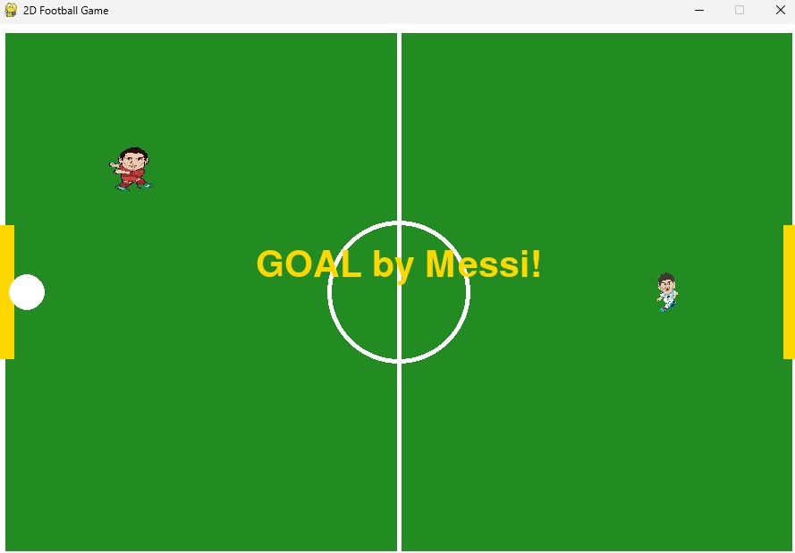
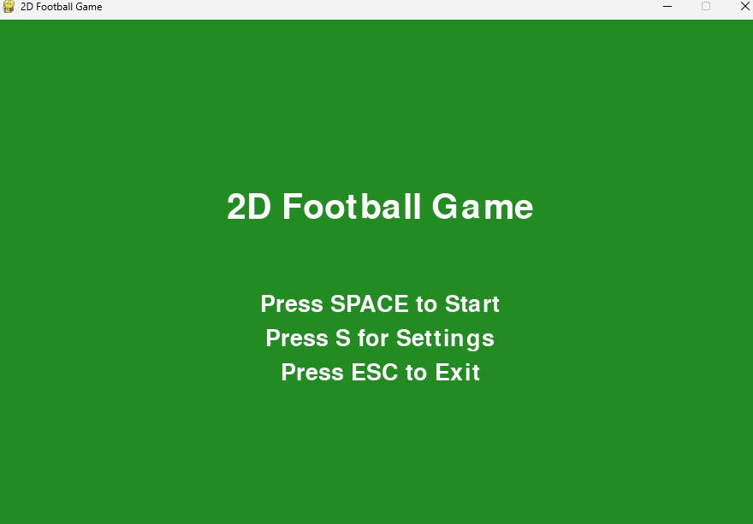

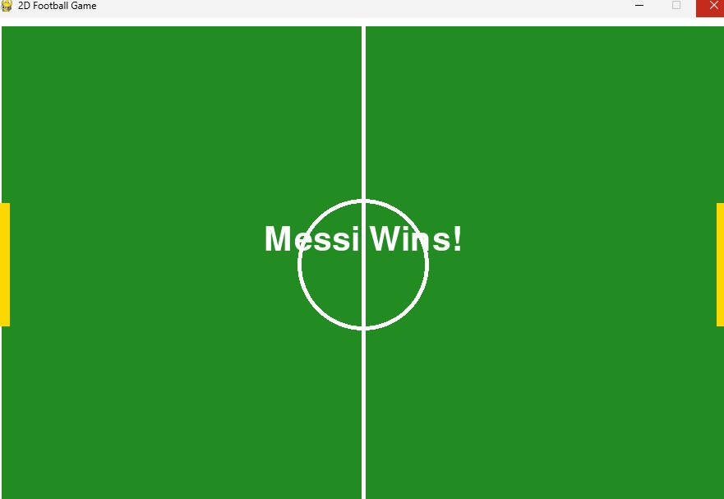

Chapter 4

Engineering Standards and Mapping

This project successfully demonstrates the application of Flex and Bison in implementing an expression converter tool. The program is capable of handling multiple conversion types and provides insight into lexical and syntax analysis as performed in compilers. This project enhances the understanding of parsing techniques and the stack-based expression evaluation process. Future improvements could include support for multi-character operands, real number inputs, and graphical interface integration.

4.1 Impact on Society and Learning:
- Enhances understanding of basic game development and AI implementation.
- Encourages learning through practical, fun programming projects.
- Demonstrates real-world use of Python and Pygame in building interactive software.
- Inspires further exploration into game engines, graphics programming, and simulation.
- Serves as a great learning module for students in AI, programming, and UI/UX design

4.2 Project Management and Collaboration:
 | Contribution
1 | UI implementation, animations, menu systems
2 | AI development, scoring system, debugging
3 | Core game logic, player movement, testing, documentation

Project management was done through weekly coordination meetings, with shared progress tracked via GitHub repository and simple task sheets. Responsibilities were divided based on module focus (logic, UI, AI), and collaboration was maintained throughout development..

4.3 Complex Problem Solving Mapping:
Mapping with Program Outcomes (POs), Course Outcomes (COs), and Problem Solving Attributes (EPs)

4.3.1 Mapping of Program Outcomes:
Table 4.1: Justification of Program Outcomes:
POs | Justification
PO1 | Engineering Knowledge: Applied knowledge of Python and game logic to design a complete playable football game with working physics and AI.
PO2 | Problem Analysis: Identified gaps in beginner-friendly Python football games and addressed user challenges through simple controls and intuitive UI.
PO3 | Design/Development of Solutions: Designed modules (AI, UI, game loop) in a structured, object-oriented way to ensure maintainability and extensibility.
PO10 | Communication: Used clear in-code comments, report documentation, and division of work to ensure alignment and collaboration during development.

4.3.2 Complex Problem Solving:

Table 4.2: Mapping with complex problem solving:
EP1 (Depth of Knowledge) | EP2 (Conflicting Req.) | EP3 (Depth of Analysis) | EP4 (Familiarity) | EP5 (Applicable Codes) | EP6 (Stakeholder) | EP7 (Interdependence)
√ | √ | √ |  | √

Explanation of Mapping:
EP1 – Depth of Knowledge Required (Mapped via CO1): Game logic required understanding of real-time input handling, collision physics, and AI behavior simulation using conditional statements and loops.
EP2 – Conflicting Requirements (Mapped via CO2): Development involved balancing fast-paced gameplay with fairness, smooth animation with performance, and challenge with simplicity.
EP3 – Depth of Analysis Required (Mapped via CO3): Designing AI behavior and scoring logic required analysis of spatial positioning, hitboxes, and timing mechanisms..
EP5 – Extent of Applicable Codes/Standards (Mapped via CO2/CO3): While no formal coding standards were required, the use of object-oriented Python, PEP-8 styling, and modular design reflects industry practices.

Chapter 5

Conclusion
This chapter provides a comprehensive overview of the project’s accomplishments, identifies current limitations, and highlights future opportunities for improvement and extension.

5.1 Summary:
The 2D Football Game project successfully fulfills its primary objective: delivering an interactive, enjoyable, and educational game experience using Python and Pygame. The project demonstrates how core programming concepts like real-time input handling, object movement, collision detection, and basic AI can be integrated to build a fully functional 2D game.
Key achievements include:
- Development of single and two-player gameplay modes
- AI-controlled player logic for solo matches
- Score tracking and timer system Simple yet effective user interface with menus and in-game HUD
- Smooth game performance and modular design
By simulating a one-on-one football match between Messi and Ronaldo, the game offers an engaging way to learn about game development and AI programming in Python.

5.2 Limitations:
Despite its success, the project has some limitations:
- The AI is reactive but not predictive; it simply tracks the ball's Y-axis.
- Visual design is basic, with limited animation and a single background.
- There is no sound or music, which could enhance the gaming experience.
- Controls are only keyboard-based, with no mouse or controller support.
- The match logic is simple—there are no fouls, stamina, or complex mechanics.
These limitations do not affect core gameplay but highlight areas for potential improvement.
5.3 Future Enhancements:
To improve and expand the project, the following enhancements are recommended:
- Advanced AI: Incorporate predictive logic or difficulty scaling.
- Sound Effects and Music: Add audio feedback for goals, kicks, and crowd reactions.
- Multiplayer Support: Explore online multiplayer using sockets or peer-to-peer libraries.
- Gamepad Support: Allow players to use controllers for a more comfortable experience.
- Visual Polish: Include animated goalkeepers, different stadiums, and power-ups.
- Player Stats: Introduce speed, strength, and stamina attributes for deeper gameplay.

References
- Pygame Documentation https://www.pygame.org/docs/
- Python Official Documentation https://docs.python.org/3/
- Real Python – Pygame Primer https://realpython.com/pygame-a-primer/
- GeeksforGeeks – Pygame Tutorials
https://www.geeksforgeeks.org/pygame-getting-started/
- Stack Overflow – Community Q&A on Pygame and Game Logic
https://stackoverflow.com/questions/tagged/pygame
- YouTube – Python Game Development Tutorials (e.g., Tech With Tim, Clear Code)
https://www.youtube.com/c/TechWithTim
https://www.youtube.com/c/ClearCode
- FreePik – Assets and Game Icons (Used in Placeholder Sprites or Menus)
https://www.freepik.com/
- W3Schools – Python Basics Reference https://www.w3schools.com/python/

